**React Assignment-1**

**Theory**

1. What is Emmet?
2. Emmet is a tool for developers which is inbuilt in many code editors like vscode, which helps to Fasten the workflow of HTML and CSS.

For ex. we can create Html boilerplate using "!” and press enter after creating a Html file using the Emmet abbreviation.

In below you can see that we created a simple Html Emmet abbreviation which is changed into a Html code snippet with a click.

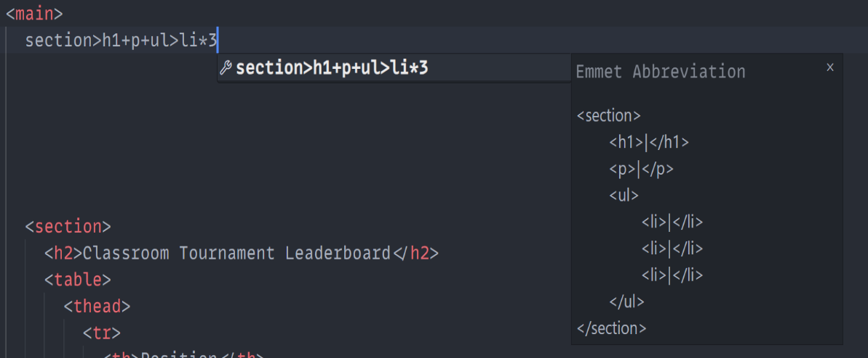

1. Difference between library and Framework?
2. A library is a collection of reusable code that provides specific functionalities or tools. You call its methods or functions whenever needed, and you control the overall flow of your application.

A framework is more like a blueprint or structure that tells you how to build your application. It’s in control and decides when and how to use your code.

1. What is CDN. Why do we use it?
2. CDN stands for Content Delivery Network is a network of servers located in different places around the world. It stores and delivers files like CSS JavaScript to users quickly.

We use it because for faster loading, reliability, scalability and security and global reach.

1. Why is React know as React?
2. React is a JavaScript library which was developed by a team of developers at Facebook. It is named as React because it’s designed to "react" efficiently to changes in data and update the user interface (UI) dynamically. Its core idea is to build responsive and interactive UIs by re-rendering only the parts of the UI that need to change, instead of the whole page.
3. What is cross-origin in a script tag?
4. The crossorigin attribute in the <script> tag is used when your script is being loaded from a different domain (a cross-origin request). It tells the browser how to handle that request.

Ex. Your app runs on http://localhost:3000, but the script is hosted on <http://localhost:8000>. In such cases, you might need crossorigin attribute to allow the browser to load the script securely while adhering to CORS rules.

1. What is Difference between React and ReactDOM?
2. React is the tool you use to create and manage the building blocks of your app, like buttons and forms. It’s like the plan for your UI**.**

**ReactDOM** is the one that takes that plan and puts it on the screen, making everything you created in React visible in the browser.

In short, **React** makes things, and **ReactDOM** shows them!

1. what is difference between react.devlopment.js and react.production.js files via CDN?
2. react.development.js is for building and testing your app. It includes extra information like error messages and warnings to help you fix problems while you're developing. But because of all these extra details, it’s larger and slower to load.

react.production.js is for when your app is ready for real users. It's smaller and faster because it doesn’t include debugging information. This version is optimized for better performance, so your app runs quickly and smoothly.

**Coding**

Github Link : https://github.com/iamgopaldev/react-assignment1